**(Internship Report)**

(Project Semester Feb-July 2022)

**“Internship at AddWebSolution Pvt Ltd”**

Submitted by:

**Ronak Jain**

**18BCON717**





*Under the Guidance of:*

**Ms. Sushama Tanwar Mr. Kaushal Mittal**

Assistant Professor – I Team Leader & Trainer

Department of CSE Industry Guide

Faculty Internship Guide

Department of Computer Science and Engineering

JECRC UNIVERSITY, JAIPUR

(2018-2022)

**PREFACE**

The present report is the outcome of the Internship Program of Full Stack Development program at Addweb Solutions Pvt Ltd. The objective of the internship program was to familiarize the student with the implementation of the knowledge he earned at the company. The practical knowledge is far different from the bookish knowledge that a student achieves in an institution.

The report focuses on a few of the important aspects of the development of Static And Dynamic Websites.

The report focuses on a few of the important aspects of the Frontend and Backend development for the product of the company.

**ACKNOLEDGEMENT**

The internship opportunity I had with Addweb Solutions Pvt Ltd was a great chance for learning and professional development. Therefore, I consider myself as a very lucky individual as I was provided with an opportunity to be a part of it. I am also grateful for having a chance to meet so many wonderful people and professionals who led me though this internship period.

Bearing in mind previous I am using this opportunity to express my deepest gratitude and special thanks to the **Rajeev Agarwal** CEO of Addweb Solutions who in spite of being extraordinarily busy with his duties, took time out to hear, guide and keep me on the correct path and allowing me to carry out my project at their esteemed organization and extending during the training.

I express my deepest thanks to **Abhishek Dhariwal** CTO for taking part in useful decision & giving necessary advices and guidance and arranged all facilities to make life easier. I choose this moment to acknowledge his/her contribution gratefully.

It is my radiant sentiment to place on record my best regards, deepest sense of gratitude to **Dr. Naveen Hemrajani**, HOD, CSE Department and my Mentor **Ms. Sushama Tanwar**, Asst. Prof. CSE Dept for their kind and active support and valuable guidance during the Internship phase. which were extremely valuable for my study both theoretically and practically.

I perceive as this opportunity as a big milestone in my career development. I will strive to use gained skills and knowledge in the best possible way, and I will continue to work on their improvement, in order to attain desired career objectives. Hope to continue cooperation with all of you in the future.

Sincerely,

Name: Ronak Jain

Reg.No: 18BCON717

Date: 21 April 2022

**DECLARATION**

I hereby declare that the projects entitled Ecommerceinstant is authentic record of my own work carried out at Addweb Solutions Pvt Ltd as requirements of Six months of industrial project for the award of degree of B.tech from JECRC University, under the guidance of Mr. Kaushal Mittal and Ms. Sushama Tanwar, during 02 Feb 2022 to July 2022.

Ronak Jain

18BCON717

Certified that the above statement made by the student is correct to the best of our knowledge.

**Ms. Sushama Tanwar**  **Mr. Kaushal Mittal**

Assistant Professor – I Industry Guide

Faculty Internship Guide

**OFFER LETTER**

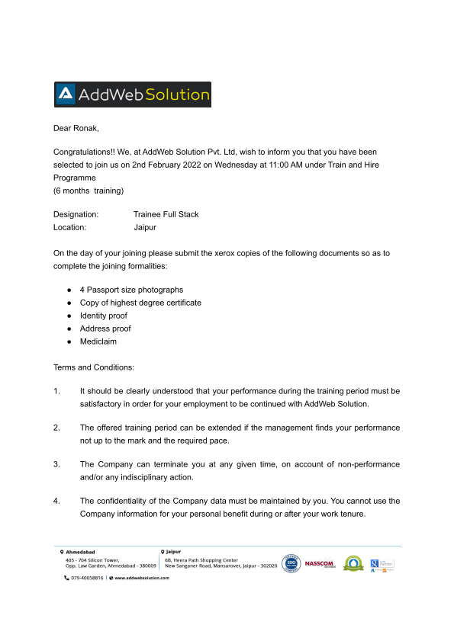

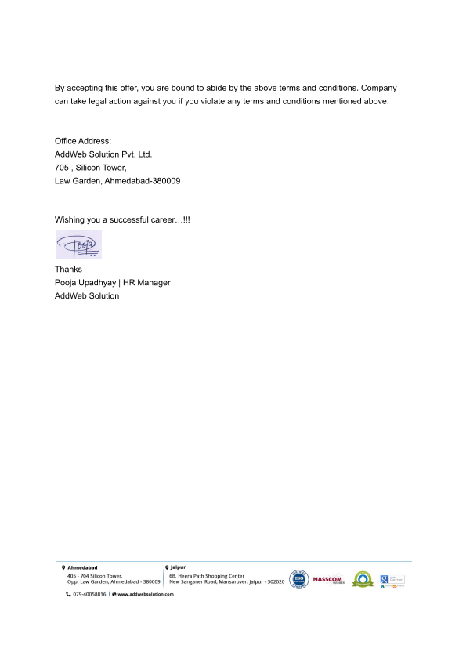

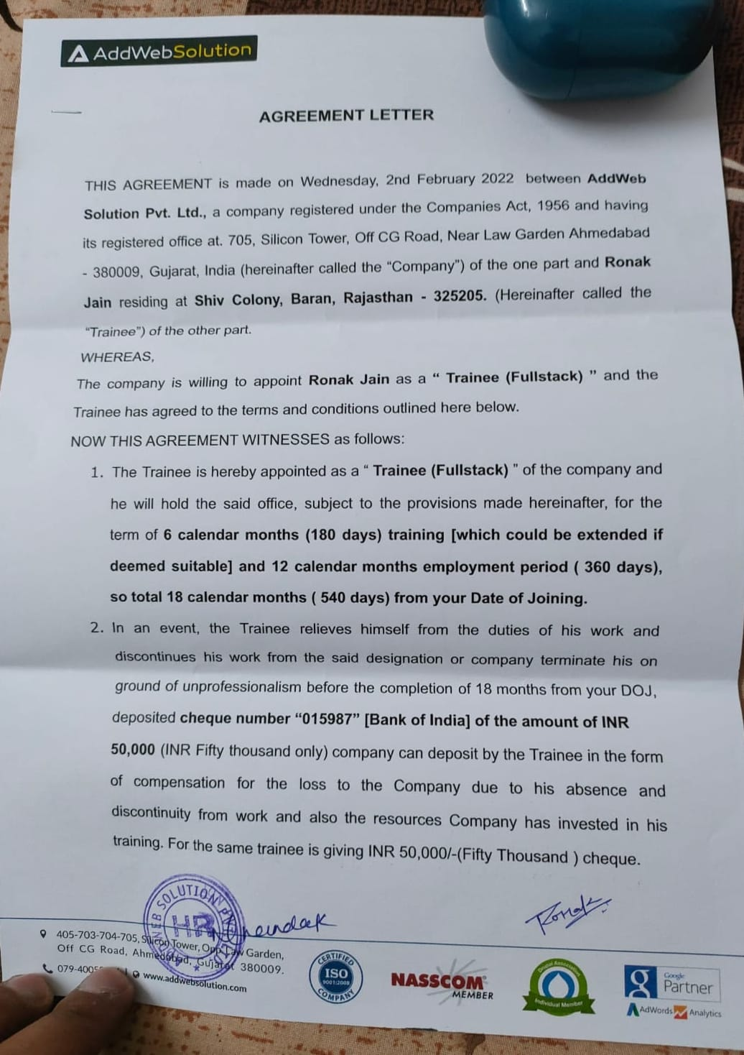**JOINING LETTER**

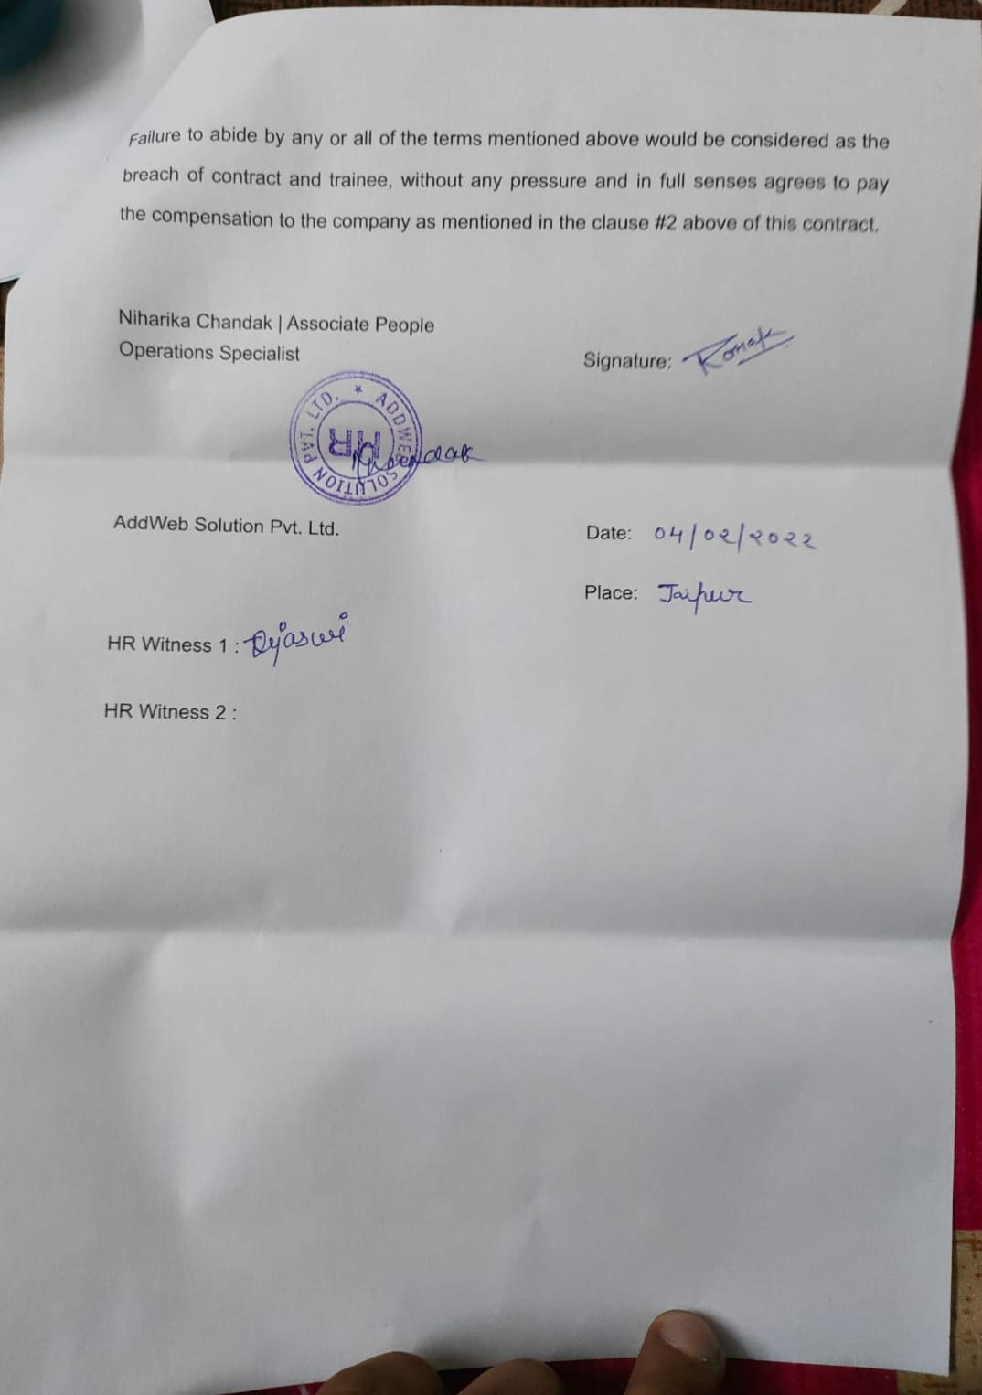

**List of Contents**

**Topic Page No.**

* Preface 02
* Acknowledgement 03
* Declaration 04
* Offer/Joining Letter 05 – 09
* Company Profile 11 – 12
* Abstract 13
* Introduction 14 - 20
* Project Work 21
* Tasks 21
* Methodology 22-27
* Product Features 28
* How it Works 29-32
* My Contribution 33
* Conclusion 34
* Recommendation 35
* Reference 36

**Company Profile [AddWeb Solution]**

AddWeb Solution is a leading IT development, consulting and outsourcing company. We have more than 24 years of experience accompanied by proud alliances with some esteemed IT and digital companies. We have also been involved in individual projects on a global scale. The balance between hyperspecialization of our services, the 360º vision & the knowledge of various sectors and businesses is the key to our service model. The company has been growing consistently due to our excellent solution and on-time deliveries. We are agile and dynamic, which gets transmitted through our work. We are super intended to boost the overall productivity of corporations by ensuring maximum ROI.

Our Services:

* Mobile App Development
* Web Application Development
* Cloud Consulting
* Ecommerce Development
* Devops
* Blockchain Development



Addweb solution is offshore Development Centre in India. You interact directly with your resources with HD quality video and the project data is secured and kept confidential.

With more than 500+ successful projects delivered we are ready to take it to the next height.

Let’s connect & talk solution!

Specialties

Website Development, Mobile Apps (iOS/Android), PHP, Wordpress, CodeIgniter, Magento, eCommerce, Yii, Laravel, CakePHP, SEO, DevOps, OctoberCMS, Server Management, VueStoreFront, SilverStripe, ReactJS, Drupal, WordPress, and Staff Augmentation

#### Bring native-like experiences to your users in half of the development cost and time with React Native App Development Services.

Offering flexible and business-specific NODE JS services to the client requirements irrespective of their domain and business size.

**Abstract**

The purpose of Online E-commerce System is to automate the existing manual system by the help of computerized equipment’s and full-fleDiscussion/ Finding/ Analysis/ Observations ( 5 pages )dged computer software, fulfilling their requirements, so that their valuable data/information can be stored for a longer period with easy accessing and manipulation of the same. The required software and hardware are easily available and easy to work with.

Online E-commerce System, as described above, can lead to error free, secure, reliable and fast management system. It can assist the user to concentrate on their other activities rather to concentrate on the record keeping. Thus it will help organization in better utilization of resources. The organization can maintain computerized records without redundant entries. That means that one need not be distracted by information that is not relevant, while being able to reach the information. Discussion/ Finding/ Analysis/ Observations ( 5 pages )

In this internship we have learnt all the languages used in front end development of the website as well as at the backend development of the websites. Some of them can be Php, MySQL, HTML, CSS, Bootstrap.

**1. INTRODUCTION**

1.1 OVERVIEW:

The central concept of the application is to allow the customer to shop virtually using the Internet and allow customers to buy the items and articles of their desire from the store. The information pertaining to the products are stores on an MYSQL at the server side (store). The Server process the customers and the items are shipped to the address submitted by them. The application was designed into two modules first Os for the customers who wish to buy the articles.Second is for the storekeepers who maintains and updates the information pertaining to the articles and those of the customers? The end user of this product is a departmental store where the application is hosted on the web and the administrator maintains the database. The application which is deployed at the customer database, the details of the items are brought forward from the database for the customer view based on the selection through the menu and the database of all the products are updated at the end of each transaction. Data entry into the application can be done through various screens designed for various levels of users. Once the authorized personnel feed the relevant data into the system, several reports could be generated as per the security.

1.2 SCOPE OF PROJECT:

Purchasing and selling products and services over the internet without the need of going physically to the market is what online shopping all about. Online shopping is just like a retail store shopping that we do by going to the market, but it is done through the internet. Online shopping has made shopping painless and added more fun. Online stores offer product description, pictures, comparisons, price and much more. Few examples of these are

Amazon.com, ebay.com, framt.com and the benefits of online shopping is that by having direct access to consumer ,the online stores can offer products that cater to the needs of consumer ,cookies can be used for tracking the customer selection over the internet or what is of their interest when they visit the site again . Online shopping makes use of digital technology for managing the flow of information, products, and payment between consumer, site owners and suppliers. Online shopping can be either B2B (business to business) or B2C(business to consumer).

Shopping cart is one of the important facility provided in online shopping, this lets customer to browse different goods and services and once they select an item to purchase they can place the item in shopping cart, and continue browsing till the final selection. Customers can even remove the items from shopping cart that were selected earlier before they place the final order. It reminds us of shopping basket that we carry in departmental store.

91.3 PURPOSE OF PROJECT:

The purpose of online shopping is to save time, save money. Through online shopping one can save his valuable time. One can watch and select things he wanna to buy. Through online shopping we can save our money because prices are less than market prices and we receive our bought things at our home. No need to go anywhere and do shopping. We can get different varieties of things online and we can choose which one we want.

1) To achieve target turnover and gross profit

2) To offer a quality experience for customers that matches the aspirations of a customer.

Online shoppingis a form of electronic commerce where the buyer is directly online to the

seller's computer usually via the internet. There is no intermediary service. The sale and

purchase transaction is completed electronically and interactively in real-time such as

Amazon.com for new books. If an intermediary is present, then the sale and purchase

transaction is called electronic commerce such as Flipcart and Amazon.

1.4 Proposed System :

The development of this new system contains the following activities, which try to develop on line application by keeping the entire process in the view of database integration approach. Secure registration and profile management facilities for Customers. Browsing through the e-Mall to see the items that are there in each category of product like Apparel, Kitchen accessories, Bath accessories, Food items etc. Creating a Shopping cart so that customer can Shoppe ‘n’ no. of items and checkout finally with the entire shopping cart.

Customers should be able to mail the Shop about the items they would like to see in the Shop Secured mechanism for checking out from the Shop( Credit card verification mechanism) Updates to customers about the Recent Items in the Shop. Uploading ‘Most Purchased’ Items in each category of products in the Shop like Apparel Kitchen accessories, Bath accessories, Food items etc

102. FEASIBILITY ANALYSIS

Feasibility study is the process of determination of whether or not a project is worthdoing.

Feasibility studies are undertaken within tight time constraints and normally culminate in awritten and oral feasibility report. I have taken two weeks in feasibility studywith my co-developer.The contents and recommendations of this feasibility study helped us as a sound basis for decidinghow to proceed the project. It helped in taking decisions such as which software to use, hardware combinations, etc.

1)Technical Feasibility

2)Economical Feasibility

3)Operational Feasibility

2.1 TECHNICAL FEASIBILITY:

Technical feasibility determines whether the work for the project can be done with theexisting equipment, software technology and available personnel. Technical feasibility is concernedwith specifying equipment and software that will satisfy the user requirement. This project is feasible on technical remarks also, as the proposed system is more beneficiary in terms of having a sound proof system with new technical components installed on thesystem. The proposed system can run on any machines supporting Windows and Internet services andworks on the best software and hardware that had been used while designing the system so it would befeasible in all technical terms of feasibility.

2.2 ECONOMICAL FEASIBIBLITY:

Economical feasibility determines whether there are sufficient benefits in creating tomake the cost acceptable, or is the cost of the system too high. As this signifies cost-benefit analysis and savings. On the behalf of the cost-benefit analysis, the proposed system is feasible and is economical regarding its pre-assumed cost for making a system.

We classified the costs of eSHOP according to the phase in which they occur. As weknow that the system development costs are usually one-time costs that will not recur after the project has been completed. For calculating the Development costs we evaluated certain cost categories viz.

1.Personal costs

2.Computer usage

3.Supply and equipments costs

4.Cost of any new computer equipments and software

2.3 OPERATIONAL FEASIBILITY:

It is mainly related to human organization and political aspects. The points to be considered are:

•What changes will be brought with the system?

113. SOFTWARE & HARDWARE REQUIREMENT

3.1 Software Requirements :

Operating System : Linux

Front End :HTML, CSS, JavaScript, Bootstrap

Back End : Php, MySql, Xampp Server

Programming Language : Php

Browser : Google Chrome 3.2 Hardware Requirements:

Processor : Intel core i7

Hard Disk : 1Tb SSD

RAM : 8GB

**METHODOLOGY**

**3.1 HTML:**

The Hypertext Markup Language or HTML (Hypertext Markup Language) is the standard markup language for documents designed to be displayed in a web browser. It can be assisted by technologies such as Cascading Style Sheets (CSS) and scripting languages such as JavaScript.

Web browsers receive HTML documents from a web server or from local storage and render the documents into multimedia web pages. HTML describes the structure of a web page semantically and originally included cues for the appearance of the document

HTML elements are the building blocks of HTML pages. With HTML constructs, images and other objects such as interactive forms may be embedded into the rendered page. HTML provides a means to create structured documents by denoting structural semantics for text such as headings, paragraphs, lists,links, quotes and other items. HTML elements are delineated by *tags*, written using angle bractets Tags such as <img/>and <input /> directly introduce content into the page. Other tags such as <p> surround and provide information about document text and may include other tags as sub-elements. Browsers do not display the HTML tags but use them to interpret the content of the page.



**3.2 CSS:**

**Cascading Style Sheets** (**CSS**) is a style sheet language used for describing the presentation of a document written in a markup language such as HTML. CSS is a cornerstone technology of the World Wide Web, alongside HTML and JavaScript.

CSS is designed to enable the separation of presentation and content, including layout, colors, and fonts. This separation can improve content accessibility, provide more flexibility and control in the specification of presentation characteristics, enable multiple web pages to share formatting by specifying the relevant CSS in a separate .CSS file which reduces complexity and repetition in the structural content as well as enabling the .CSS file to be cached to improve the page load speed between the pages that share the file and its formatting. Separation of formatting and content also makes it feasible to present the same markup page in different styles for different rendering methods, such as on- screen, in print, by voice (via speech-based browser or screen reader), and on Braille-based tactile devices. CSS also has rules for alternate formatting if the content is accessed on a mobile device.



**3.3 JavaScript:**

JavaScript, often abbreviated as JS, is a programming language that conforms to the ECMAScript specification. JavaScript is high-level, often just-in-time compiled, and multi-paradigm. It has curly-bracket syntax, dynamic typing, prototype-based object-orientation, and first-class functions.

Alongside HTML and CSS, JavaScript is one of the core technologies of the World Wide Web. JavaScript enables interactive web pages and is an essential part of web \applications. The vast majority of websites use it for client-side page behavior, and all major web browsers have a dedicated JavaScript engine to execute it.

As a multi-paradigm language, JavaScript supports event-driven, functional, and imperative programming styles. It has application programming interfaces (APIs) for working with text, dates, regular expressions, standard data structures, and the Document Object Model (DOM).



Do not confuse JavaScript with the Java programmimg language. Both "Java" and "JavaScript" are trademarks or registered trademarks of Oracle in the U.S. and other countries. However, the two programming languages have very different syntax, semantics, and use.

**3.4 Php Language:**

PHP is a general-purpose scripting language especially suited to web

development. It was originally created by Danish-Canadian programmer Rasmus Lerdorf in 1994. The PHP reference implementation is now produced by The PHP Group. PHP originally stood for Personal Home Page, but it now stands for the recursive initialism PHP: Hypertext Preprocessor.



**3.5 Bitbucket:**

Bitbucket is our Git repository management solution designed for professional teams. It gives you a central place to manage git repositories, collaborate on your source code and guide you through the development flow.

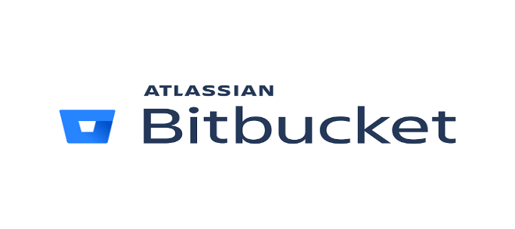

**3.6 VS Code:**

Visual Studio Code is a streamlined code editor with support for development operations like debugging, task running, and version control. It



aims to provide just the tools a developer needs for a quick code-build-debug cycle and leaves more complex workflows to fuller featured IDEs, such as Visual Studio IDE.

**3.7 Docker:**

Docker is an open-source containerization platform. It enables developers to package applications into containers—standardized executable components combining application source code with the operating system (OS) libraries and dependencies required to run that code in any environment.

Docker is an operating system virtualization technology that allows applications to be packaged as containers. This is a very fundamental part of cloud computing, as containerized applications can be run on any type of infrastructure, regardless of the provider.

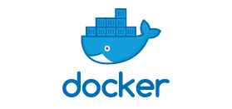

**3.8 Kubernetecs:**

Kubernetes, often abbreviated as “K8s”, orchestrates containerized applications to run on a cluster of hosts. The K8s system automates the deployment and management of cloud native applications using on-premises infrastructure or public cloud platforms.

Pure open source Kubernetes is free and can be downloaded from its repository on GitHub. Administrators must build and deploy the Kubernetes release to a local system or cluster -- or to a system or cluster in a public cloud, such as AWS, Google Cloud or Microsoft Azure.



**3.9 Jenkins:**

Jenkins is an open source automation server. It helps automate the parts of software development related to building, testing, and deploying, facilitating continuous integration and continuous delivery. It is a server-based system that runs in servlet containers such as Apache Tomcat. It supports version control tools, including AccuRev, CVS, Subversion, Git, Mercurial, Perforce, ClearCase and RTC, and can execute Apache Ant, Apache Maven and sbt based projects as well as arbitrary shell scripts and Windows batch commands.



**4.0 AWS:**

Amazon Web Services (AWS) is a secure cloud services platform, offering compute power, database storage, content delivery and other functionality to help businesses scale and grow. Running web and application servers in the cloud to host dynamic websites.

AWS provides services that help you practice DevOps at your company and that are built first for use with AWS. These tools automate manual tasks, help teams manage complex environments at scale, and keep engineers in control of the high velocity that is enabled by DevOps.

**4.1 Azure:**

Azure is a cloud computing platform and an online portal that allows you to access and manage cloud services and resources provided by Microsoft. These services and resources include storing your data and transforming it, depending on your requirements.



**4.2 IBM:**

IBM Cloud is a suite of cloud computing services from IBM that offers both platform as a service (PaaS) and infrastructure as a service (IaaS).



**4.3 GCP:**

GCP is a public cloud vendor that offers a suite of computing services to do everything from data management to delivering web and video over the web to AI and machine learning tools. Customers are able to access computer resources housed in Google's data centers around the world for free or on a pay-per-use basis.



**4.4 Postman:**

Postman is an application used for API testing. It is an HTTP client that tests HTTP requests, utilizing a graphical user interface, through which we obtain different types of responses that need to be subsequently validated.



**4.5 RDS:**

Amazon RDS is a managed relational database service that provides you six familiar database engines to choose from, including Amazon Aurora, MySQL, MariaDB, Oracle, Microsoft SQL Server, and PostgreSQL.

Amazon Relational Database Service (RDS) is a managed SQL database service provided by Amazon Web Services (AWS). Amazon RDS supports an array of database engines to store and organize data. It also helps with relational database management tasks, such as data migration, backup, recovery and patching.



**4.6 NoSql:**

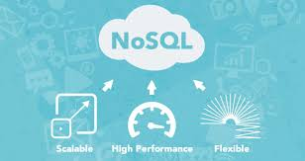NoSQL databases (aka "not only SQL") are non-tabular databases and store data differently than relational tables. NoSQL databases come in a variety of types based on their data model. The main types are document, key-value, wide-column, and graph. They provide flexible schemas and scale easily with large amounts of data and high user loads.

**Microsec.ai Product Features**

Microsec.ai Launches First Solution to Deliver Agentless Runtime Protection for Multi-cloud Infrastructure as a Service.

* **ONE UNIFIED PROTECTION PLATFORM FOR ALL YOUR MULTI-CLOUD RESOURCES**

     

**PROTECT YOUR DATA CONTINUOUS SECURITY**

* Data classification at-rest/in-motion Cloud account security
* Enterprise DLP integration Misconfiguration detection
* East-west data detection and control Compliance reporting
* Exposure analysis and remediation Security analytics
* Encryption status Anomaly detection

**PROTECT APPS IN RUNTIME**

* Intrusion detection
* VM & container security
* Application and network visibility
* Threat investigations & resolution
* Adaptive east-west micro segmentation

**COMPLIANCE**

* CIS benchmark
* PCI-DSS
* SOC 2
* HIPAA
* NIST

**How Microsec.ai Works ?**

**Deploy & start protecting your cloud in 5 minutes Microsec.ai connects to your cloud with an API. It doesn’t require you to install agents or sidecars and once it’s on…it’s on.**

1. Easy agentless deployment, just connect your cloud API
2. Simple cloud-native overlay with centralized responsive policies
3. Auto discovery of assets with one-click
4. Continuous scanning and analysis of micro services and applications
5. Self-healing protection and optional service mesh integration

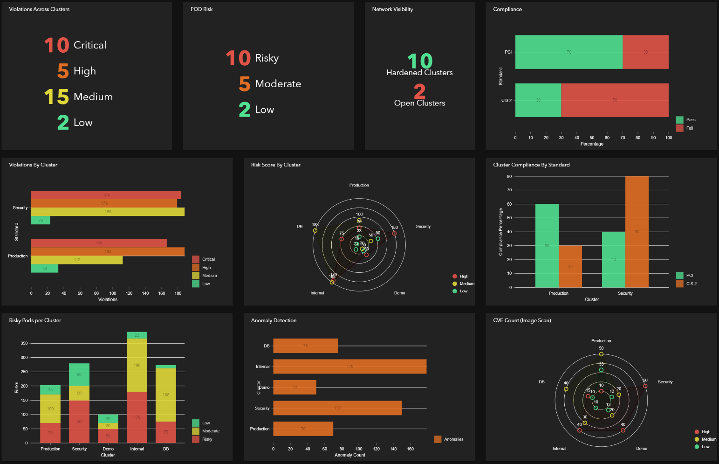

Continuously monitor and improve your cloud security. Microsec.ai will perform cloud security posture management (CSPM) and cloud workload protection (CWP) automatically within the context of your running network and data protection. Stop relying on static, disparate security assessment reports – by the time you get that daily report and figure out what to prioritize, it’s too late.

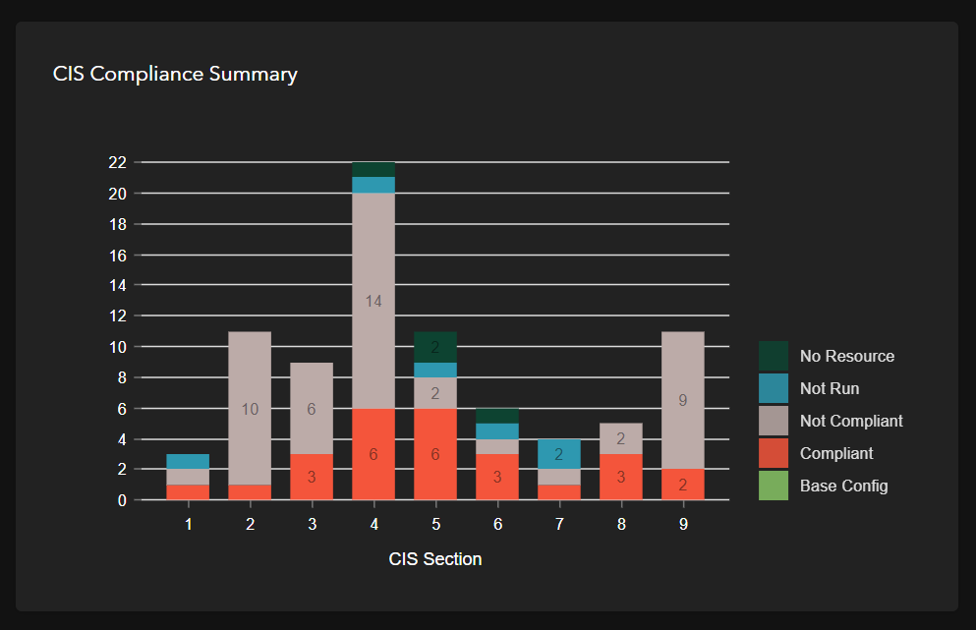

1. Continuous discovery and security monitoring for cloud environments
2. Continuous compliance posture reporting for CIS, PCI DSS, SOC 2, NIST, etc.
3. Automatically detect and fix misconfigurations and vulnerabilities fast
4. Respond right away to risky activity with anomaly detection for API behaviors & audit logs
5. Prioritize and automate with AI-driven risk intelligence

**MAINTAIN UPTIME: AUTOMATICALLY MITIGATE ATTACKS WITH SELF HEALING NETWORK MICROSEGMENTATION**

Respond fast when attacks happen with an AI system that continuously analyzes traffic to identify risky and anomalous activity. See what’s happening in real-time with dynamic dashboards. Simply point and click to cut traffic flows or set response policies to automatically isolate and replace at-risk services in runtime.



1. Detect and remediate threats to applications, microservices, and containers in runtime
2. Identify and block intrusions with machine learning systems
3. Replace and isolate at-risk assets with adaptive runtime micro segmentation
4. Accelerate response times with dynamic “click to fix” dashboards
5. Automate alerts and mitigation through central policies and service mesh integration

**PROTECT YOUR DATA WITH INTEGRATED DLP**

Protect the regulated and highly sensitive data in your cloud infrastructure. Get visibility into east-west dataflows and everywhere you store your data.

1. Monitor east-west data-in-motion and block data flowing to unauthorized APIs, zones, and workloads.
2. Track who and what has access to data-at-rest in persistent storage and databases
3. Detect & classify sensitive data so you know exactly where the data you must protect is located
4. Automate remediation policies to remove public links or block risky access to prevent data breach
5. Save time by extending your existing DLP to your cloud environments via integration (Broadcom, AWS, Google…)

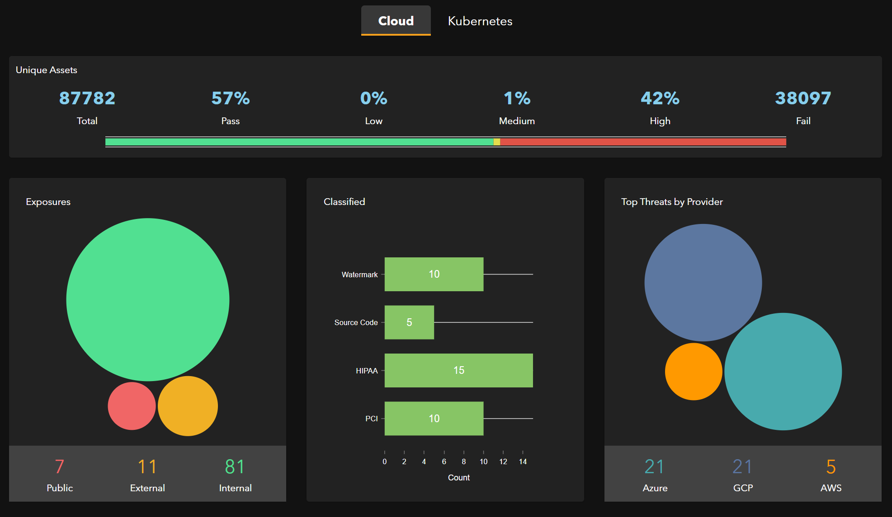

**My Contribution**

* As a Python developer, My role is to work on the assigned task for the development of the product. I assigned tasks like Aws Data Submission, VM snapshotting, Open ports, etc.
* As a team member of DLP also called as Data loss prevention, I need to take care of a lot of data’s which are present inside different databases in the clouds with different virtual machines.
* Developing the requirements by the clients and product, we need to touch the customers requirements so that any client will buy our products in an effective manner.
* I use to implement various Apis using fast API so that the UI team can integrate it into the company product.
* I need to work on different clouds for the same task simultaneously.
* Sometime I use to test API’s which are implemented by the developers of different teams.
* For touching the EOD, most of the time we as a team use to work separately by dividing the modules into sub modules.
* Integrating, developing and deploying is my foremost role towards the development of the product and growth of the company.

**CONCLUSION**

* From this Internship of 3 months till now, I get to know about the company environment like how the company works on such kind of projects.
* I learnt about different tools and technology which are use to develop any product.
* Using my theoretical knowledge, I got the chance to implement them practically with live projects.
* I can able to get improve my logics much better than before.
* I get Hands on experience with Python technology and worked on different cloud.
* I am now able to work on both frontend and backend for the web Applications.
* I learnt about how to handle huge amount of data from any client or company.
* How Vm works on clouds and how it will be implemented using codes, I get hands on experience on it.
* I also get a chance to learn about Data Science and ML for the product.
* One of the latest technology, docker and k8s, I get to learn and implement using this too.
* I've observed my skills grow these past 3 months.
* Till now this internship has been an excellent and rewarding experience for me and I hope I could continue this way. I can conclude that there has been a lot I've been learning from my work at Microsec. The technical aspects of the work I've done are not flawless and could be improved provided enough time.

**Recomandations**

I think that having a deal with projects and learning during this Internship has been helpful for me to learn lots of Industrial knowledge. I have worked full time on many modules. Microsec.ai Security organization allowed me to take part from the beginning in all sort of work i.e. Backend and Database. Many modules are prepared before and proposed to me to motivate and take part in those projects. Working with the Companies was profitable to me, so I would recommend to take more and more projects with clients. Doing an Internship with the Microsec.ai Security made me realize how interesting and stimulating Internship can be.

**References**

* **W3 Schools** <https://www.w3schools.com/>
* **Stack Overflow:** <https://stackoverflow.com/>
* **Microsec ai Security**: <https://microsec.ai/>
* **Google**: [https://google.com](https://google.com/)
* **Wikipedia**: <https://en.wikipedia.org/wiki/Jira_(software)>

**(Industrial Project Synopsis)**

(Project Semester Jan-June 2022)

**“Internship at Microsec.ai Security”**

Submitted in for the partial fulfilment of the degree

by

**Shubham Kumar**

**Student Reg. no: 18BCON459**

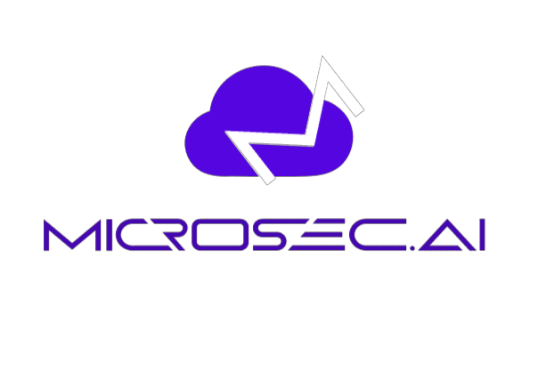



*Under the Guidance of:*

**Ms. Sushama Tanwar Mr. Jayant Byadwal**

Assistant Professor – I CEO at Microsec.ai Security

Department of CSE Technical Expert

Faculty Internship Guide Industry Guide

Department of Computer Science and Engineering

JECRC UNIVERSITY, JAIPUR

(2022)

**DECLARATION**

I hereby declare that the projects entitled **Cloud Security Software** is authentic record of my own work carried out at Microsec.ai Security as requirements of Six months of industrial project for the award of degree of B.tech from JECRC University, under the guidance of Mr. Jayant Byadwal and Ms. Sushama Tanwar, during 10 Jan 2022 to June 2022.

Shubham Kumar

18BCON459

Certified that the above statement made by the student is correct to the best of our knowledge.

**Ms. Sushama Tanwar**  **Mr. Jayant Byadwal**

Assistant Professor – I CEO at Microsec.ai Security

Faculty Internship Guide Industry Guide

**List of Content**

**Nomenclature Page no.**

* Page Title 37
* Declaration 38
* Abstract 40
* Overview of project 41
* Technology used 42
* Feasibility Study 44
* Conclusion 45

**Abstract**

Included in this paper are accounts of my Internship undertaken in the fulfilment of my B.Tech CSE degree from JECRC University. The Internship is with Microsec.ai Security Jaipur Rajasthan.

In this Internship I have learnt all the languages used in Backend development of the web application as well as at the Server side development of the websites. Some of them can be Python lang, Fast API, Bitbucket, Cloud Computing, DBMS

I have been working on our own company product. So included all the links and sample images for the same and gained. Leadership, confidence, determination. Increased technical knowledge while implementing those ideas.

**Overview**

**Microsec.ai Security:**

Microsec is backed by top venture funds, industry luminaries, and strategic partners. The Microsec.ai solution is an agentless, runtime Cloud Native Application Protection Platform (CNAPP) created to secure and protect multi-cloud IaaS and PaaS environments, containers, and data in one unified solution.

* One-click discovery and real-time visibility
* Cloud security posture management (CSPM) with runtime monitoring
* Cloud workload protection platform (CWPP) with self-healing micro segmentation
* Data loss prevention (DLP)

As an agentless solution, Microsec.ai delivers value in minutes. The only Cloud Native Application Protection Platform (CNAPP) to operate in runtime with east-west traffic control and DLP, Microsec.ai secures and protects multi-cloud IaaS and PaaS environments, containers, and data in one unified solution.

Full data loss prevention (DLP) capabilities automatically protect sensitive data at rest, and in motion. Network and architecture graph dashboards show resource relationships, sensitive data, traffic, vulnerabilities, misconfigurations, and compliance posture in context with instant click-to-fix capabilities. Microsec.ai performs cloud security posture management (CSPM) and cloud workload protection (CWP) automatically and continuously protects cloud native applications and data through ML-based detections and responsive policies.



Microsec.ai was founded by industry veterans Mitthan Meena and Deena Thomchick who were instrumental in the development of one of the most successful Cloud Access Security Broker (CASB) solutions on the market. In Microsec.ai, they plan to deliver protection for IaaS environments that’s even more dynamic and comprehensive than CASB for Software as a Service.

**Technology Used**

**Python language:**

Python is a high-level, general-purpose programming language. Its design philosophy emphasizes code readability with the use of significant indentation. Its language constructs and object-oriented approach aim to help programmers write clear, logical code for small- and large-scale projects.

**Bitbucket:**

Bitbucket is our Git repository management solution designed for professional teams. It gives you a central place to manage git repositories, collaborate on your source code and guide you through the development flow.

**VSCode:**

Visual Studio Code is a streamlined code editor with support for development operations like debugging, task running, and version control. It aims to provide just the tools a developer needs for a quick code-build-debug cycle and leaves more complex workflows to fuller featured IDEs, such as Visual Studio IDE.

**Fast API:**

Fast API is a modern, fast (high-performance), web framework for building APIs with Python 3.6+ based on standard Python type hints.

**PostMan:**

Postman is an application used for API testing. It is an HTTP client that tests HTTP requests, utilizing a graphical user interface, through which we obtain different types of responses that need to be subsequently validated.

**MySQL:**

MySQL is a relational database management system based on SQL – Structured Query Language. The application is used for a wide range of purposes, including data warehousing, e-commerce, and logging applications. The most common use for MySQL however, is for the purpose of a web database.

**Docker:**

Docker is an open-source containerization platform. It enables developers to package applications into containers—standardized executable components combining application source code with the operating system (OS) libraries and dependencies required to run that code in any environment.

**Virtual Machines**:

A Virtual Machine (VM) is a compute resource that uses software instead of a physical computer to run programs and deploy apps. One or more virtual “guest” machines run on a physical “host” machine.

**Feasibility Study**

System testing is the stage of implementation, which is aimed at ensuring that the system works accurately and efficiently before live operation commences. Testing is the process of executing the program with the intent of finding errors and missing operations and also a complete verification to determine whether the objectives are met and the user requirements are satisfied. The ultimate aim is quality assurance.

Tests are carried out and the results are compared with the expected document. In the case of erroneous results, debugging is done. Using detailed testing strategies a test plan is carried out on each module. The various tests performed in “Network Backup System” are unit testing, integration testing and user acceptance testing.

**Unit Testing:**

The software units in a system are modules and routines that are assembled and integrated to perform a specific function. Unit testing focuses first on modules, independently of one another, to locate errors. This enables, to detect errors in coding and logic that are contained within each module. This testing includes entering data and ascertaining if the value matches to the type and size supported by java. The various controls are tested to ensure that each performs its action as required.

**Integration Testing:**

Data can be lost across any interface, one module can have an adverse effect on another, sub functions when combined, may not produce the desired major functions. Integration testing is a systematic testing to discover errors associated within the interface. The objective is to take unit tested modules and build a program structure. All the modules are combined and tested as a whole. Here the Server module and Client module options are integrated and tested. This testing provides the assurance that the application is well integrated functional unit with smooth transition of data.

**User Acceptance testing:**

User acceptance of a system is the key factor for the success of any system. The system under consideration is tested for user acceptance by constantly keeping in touch with the system users at time of developing and making changes whenever required.

**Conclusion**

* From this Internship of 3 months till now, I get to know about the company environment like how the company works on such kind of projects.
* I learnt about different tools and technology which are use to develop any product.
* Using my theoretical knowledge, I got the chance to implement them practically with live projects.
* I can able to get improve my logics much better than before.
* I get Hands on experience with Python technology and worked on different cloud.
* I am now able to work on both frontend and backend for the web Applications.
* I learnt about how to handle huge amount of data from any client or company.
* How Vm works on clouds and how it will be implemented using codes, I get hands on experience on it.
* Till now this internship has been an excellent and rewarding experience for me and I hope I could continue this way. I can conclude that there has been a lot I've been learning from my work at Microsec. The technical aspects of the work I've done are not flawless and could be improved provided enough time.